 Assignment 5

Name : Aditya Latke
PRN : 1262252462
DIV : 1

PROBLEM STATEMENT:
Write a program in C to perform basic matrix operations such as:
1. Addition of two matrices
2. Saddle point of a matrix
3. Inverse of a matrix
4. Magic square of a matrix

OBJECTIVE:
• To understand matrix representation in C using two-dimensional arrays.
• To implement various matrix operations using C programming.
• To develop logical thinking for solving matrix-based problems.

THEORY:
Matrix operations are widely used in engineering and scientific applications. Addition of matrices involves adding corresponding elements. A saddle point is an element that is the minimum in its row and maximum in its column. The inverse of a matrix exists only for square matrices with non-zero determinant. A magic square is a square matrix in which the sums of elements in each row, column, and diagonals are equal.

1. Addition of Two Matrices
Definition:
Addition of matrices involves adding corresponding elements of two matrices.
Matrix addition is possible only if both matrices have the same order.

Example:
Let


2. Saddle Point of a Matrix
Definition:
A saddle point is an element in a matrix which is:
- Minimum in its row
- Maximum in its column
If a matrix has a saddle point, it is said to have a stable point.

Example:

- Element 4 is the minimum in its row
- Element 4 is the maximum in its column
Hence, 4 is the saddle point.

3. Inverse of a Matrix
Definition:
The inverse of a matrix exists only for square matrices whose determinant is non-zero.
If AAA is a matrix and A−1A^{-1}A−1 is its inverse, then:
where I is the identity matrix.

Example:
Determinant:
Since determinant ≠ 0, inverse exists.

4. Magic Square of a Matrix
Definition:
A magic square is a square matrix in which the sum of elements in each row, each column, and both diagonals is equal.

Example (3 × 3 Magic Square):


- Sum of each row = 15
- Sum of each column = 15
- Sum of both diagonals = 15
Hence, it is a magic square.
PLATFORM:
Linux

ALGORITHM:
1. Start
2. Read the order of the matrix
3. Read elements of the matrices
4. Perform matrix addition
5. Check for saddle point
6. Find inverse of the matrix (if determinant ≠ 0)
7. Check whether the matrix is a magic square
8. Display results
9. Stop

PROGRAM:
#include <stdio.h>
#include <math.h>

int main()
{
int choice;
int i, j, k;

printf("\nMATRIX OPERATIONS MENU");
printf("\n1. Addition of two matrices");
printf("\n2. Saddle point of a matrix");
printf("\n3. Inverse of a matrix (2x2)");
printf("\n4. Magic square check");
printf("\nEnter your choice: ");
scanf("%d", &choice);

switch(choice)
{
// ------------------ 1. Matrix Addition ------------------
case 1:
{
int r, c;
int A[10][10], B[10][10], C[10][10];

printf("Enter number of rows and columns: ");
scanf("%d %d", &r, &c);

printf("Enter elements of Matrix A:\n");
for(i = 0; i < r; i++)
for(j = 0; j < c; j++)
scanf("%d", &A[i][j]);

printf("Enter elements of Matrix B:\n");
for(i = 0; i < r; i++)
for(j = 0; j < c; j++)
scanf("%d", &B[i][j]);

for(i = 0; i < r; i++)
for(j = 0; j < c; j++)
C[i][j] = A[i][j] + B[i][j];

printf("Resultant Matrix:\n");
for(i = 0; i < r; i++)
{
for(j = 0; j < c; j++)
printf("%d ", C[i][j]);
printf("\n");
}
break;
}

// ------------------ 2. Saddle Point ------------------
case 2:
{
int r, c;
int a[10][10];
int saddle = 0;

printf("Enter rows and columns: ");
scanf("%d %d", &r, &c);

printf("Enter matrix elements:\n");
for(i = 0; i < r; i++)
for(j = 0; j < c; j++)
scanf("%d", &a[i][j]);

for(i = 0; i < r; i++)
{
int min = a[i][0];
int col = 0;

for(j = 1; j < c; j++)
{
if(a[i][j] < min)
{
min = a[i][j];
col = j;
}
}

int flag = 1;
for(k = 0; k < r; k++)
{
if(a[k][col] > min)
{
flag = 0;
break;
}
}

if(flag)
{
printf("Saddle Point = %d\n", min);
saddle = 1;
}
}

if(!saddle)
printf("No Saddle Point found\n");

break;
}

// ------------------ 3. Inverse of Matrix ------------------
case 3:
{
float a[2][2], inv[2][2];
float det;

printf("Enter elements of 2x2 matrix:\n");
for(i = 0; i < 2; i++)
for(j = 0; j < 2; j++)
scanf("%f", &a[i][j]);

det = a[0][0]*a[1][1] - a[0][1]*a[1][0];

if(det == 0)
{
printf("Inverse does not exist (Determinant = 0)\n");
}
else
{
inv[0][0] = a[1][1] / det;
inv[0][1] = -a[0][1] / det;
inv[1][0] = -a[1][0] / det;
inv[1][1] = a[0][0] / det;

printf("Inverse Matrix:\n");
for(i = 0; i < 2; i++)
{
for(j = 0; j < 2; j++)
printf("%.2f ", inv[i][j]);
printf("\n");
}
}
break;
}

// ------------------ 4. Magic Square ------------------
case 4:
{
int n;
int a[10][10];
int sum = 0, temp = 0;
int magic = 1;

printf("Enter order of square matrix: ");
scanf("%d", &n);

printf("Enter elements:\n");
for(i = 0; i < n; i++)
for(j = 0; j < n; j++)
scanf("%d", &a[i][j]);

for(j = 0; j < n; j++)
sum += a[0][j];

for(i = 1; i < n; i++)
{
temp = 0;
for(j = 0; j < n; j++)
temp += a[i][j];
if(temp != sum)
magic = 0;
}

for(j = 0; j < n; j++)
{
temp = 0;
for(i = 0; i < n; i++)
temp += a[i][j];
if(temp != sum)
magic = 0;
}

temp = 0;
for(i = 0; i < n; i++)
temp += a[i][i];
if(temp != sum)
magic = 0;

temp = 0;
for(i = 0; i < n; i++)
temp += a[i][n-i-1];
if(temp != sum)
magic = 0;

if(magic)
printf("It is a Magic Square\n");
else
printf("It is NOT a Magic Square\n");

break;
}

default:
printf("Invalid Choice\n");
}

return 0;
}

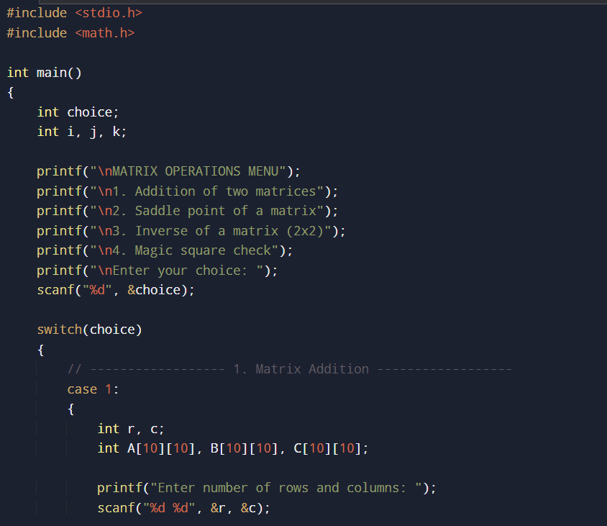
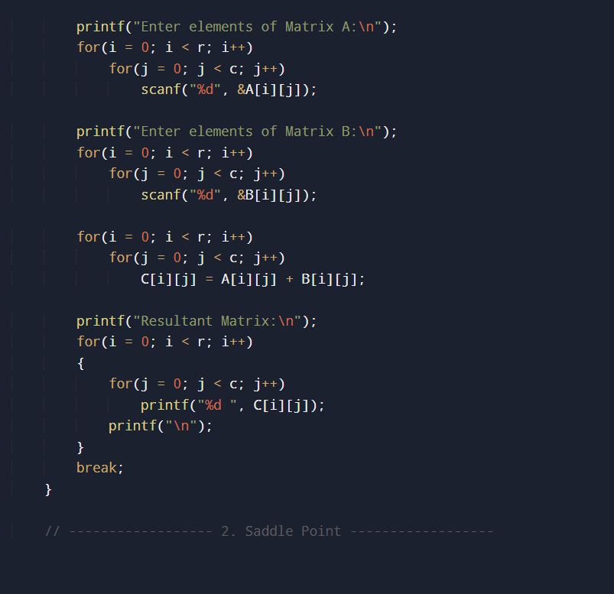
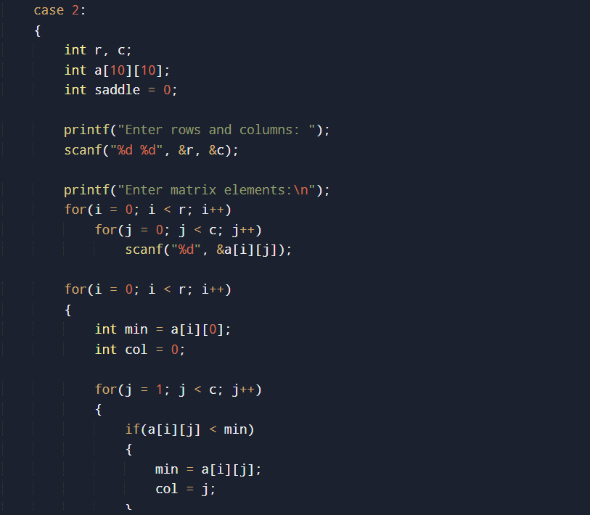
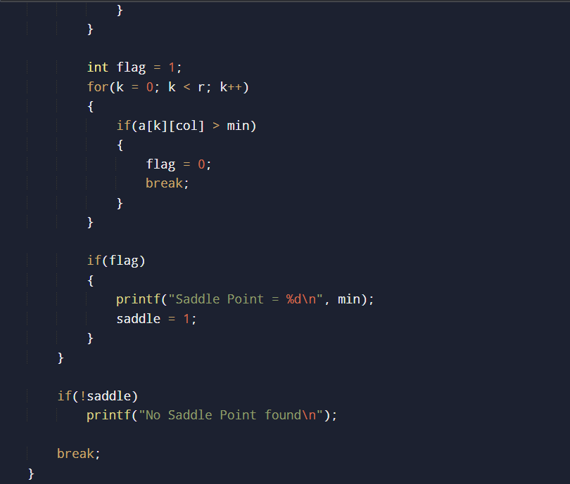
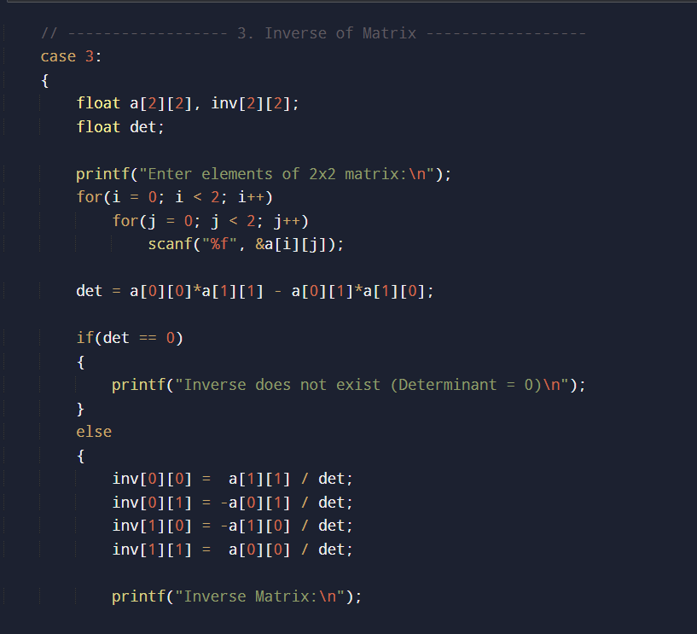
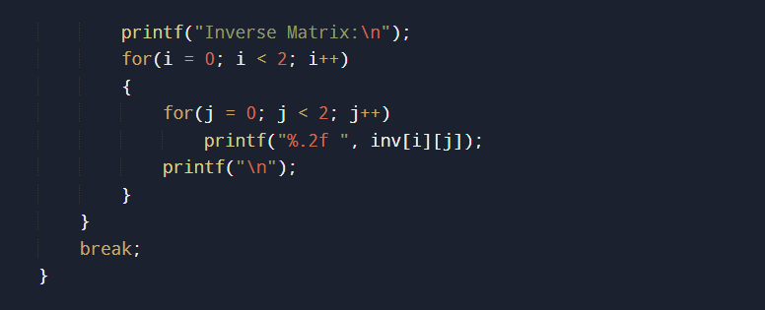
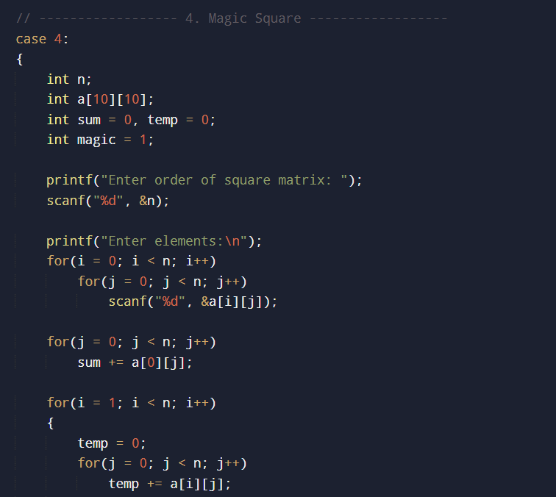
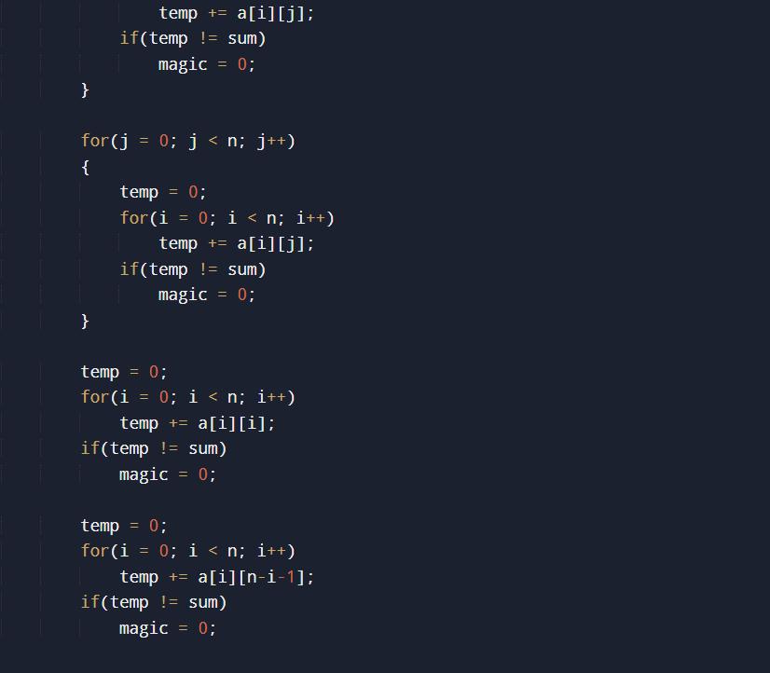
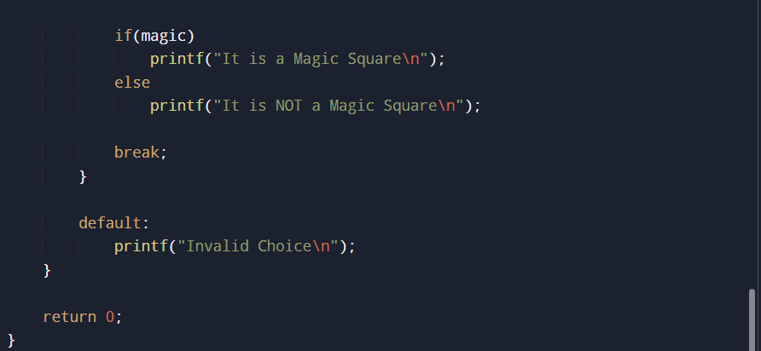

INPUT:

MATRIX OPERATIONS MENU
1. Addition of two matrices
2. Saddle point of a matrix
3. Inverse of a matrix (2x2)
4. Magic square check
Enter your choice: 1
Enter number of rows and columns: 3
3
Enter elements of Matrix A:
3
4
5
6
8
9
7
6
6
Enter elements of Matrix B:
7
8
7
6
5
7
8
8
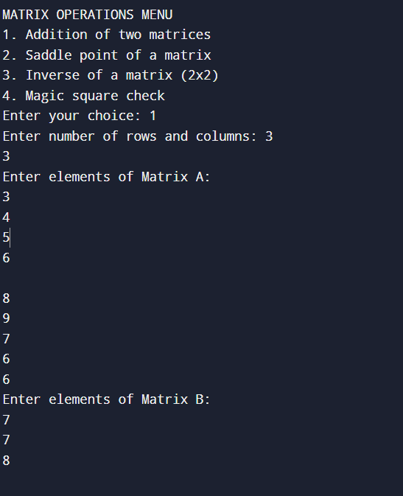

OUTPUT:
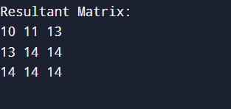
Resultant Matrix:
10 11 13
13 14 14
14 14 14

CONCLUSION:
Thus, we have learned how to perform basic matrix operations using C programming and understood their practical applications.

FAQs:
1. What is a saddle point in a matrix?
2. When does a matrix have an inverse?
3. What is a magic square?

